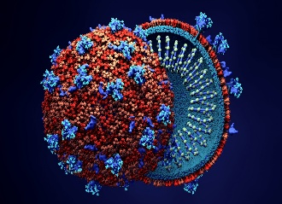**What are Viral Infections**? Viral infections occur when a virus enters a host's body and replicates, causing harm to the host's cells and tissues. Viruses are tiny particles that can't reproduce on their own and need a host cell to replicate.

1. **Causes of Viral Infections**. Viral infections can be spread through various routes, including:
   * **Airborne transmission**: Viruses like influenza, COVID-19, and measles can be spread through respiratory droplets that are released when an infected person talks, coughs, or sneezes.
   * **Direct contact**: Viruses like herpes simplex, HIV, and hepatitis B can be spread through skin-to-skin contact, bodily fluids, or contaminated needles.
   * **Contaminated food and water**: Viruses like norovirus and rotavirus can be spread through contaminated food and water.
   * **Vector-borne transmission**: Viruses like dengue fever, Zika virus, and yellow fever can be spread through the bite of an infected insect.
2. 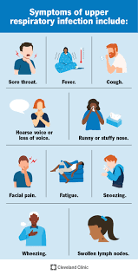**Symptoms of Viral Infections**. The symptoms of viral infections vary depending on the type of virus and the severity of the infection. Common symptoms include:
   * **Fever**: An elevated body temperature, usually above 100.4°F (38°C).
   * **Fatigue**: Feeling tired or exhausted.
   * **Muscle aches**: Pain or discomfort in the muscles.
   * **Cough**: A respiratory symptom that can range from mild to severe.
   * **Sore throat**: Pain or discomfort in the throat.
3. **Treatment Options for Viral Infections**. While some viral infections have specific treatments, many are self-limiting and resolve on their own with supportive care. Treatment options include:
   * **Antiviral medications**: Medications that specifically target viruses, such as acyclovir for herpes simplex or oseltamivir for influenza.
   * **Supportive care**: Rest, hydration, and over-the-counter medications to relieve symptoms like fever, headache, and muscle aches.
   * **Hospitalization:** In severe cases, hospitalization may be necessary to provide supportive care, such as oxygen therapy, IV fluids, and monitoring.
4. **Prevention Strategies**. Preventing viral infections requires a combination of individual and community-level efforts. Some strategies include:
   * **Vaccination**: Vaccines are available for many viral infections, including influenza, HPV, hepatitis A and B, and COVID-19.
   * **Good hygiene**: Frequent hand washing, avoiding close contact with infected individuals, and proper disposal of contaminated materials.
   * **Vector control**: Eliminating breeding sites for insects that transmit viruses, using insect repellents, and wearing protective clothing.
5. **Common Viral Infections**. Some common viral infections include:
   * **Influenza**: A respiratory virus that can cause mild to severe illness.
   * **COVID-19:** A respiratory virus that can cause mild to severe illness, including pneumonia and acute respiratory distress syndrome.
   * **Herpes simplex**: A viral infection that causes cold sores or genital herpes.
   * **HIV**: A viral infection that attacks the immune system and can cause AIDS if left untreated.
   * **Norovirus**: A highly contagious virus that causes gastrointestinal symptoms like diarrhea and vomiting.
6. **Prevention** 
   * **General Measures**
     1. **Stay hydrated:** Drink plenty of fluids, such as water, clear broths, or electrolyte-rich beverages like coconut water or sports drinks.
     2. **Rest**: Get plenty of rest to help your body fight off the infection.
     3. **Maintain good hygiene**: Wash your hands frequently, avoid close contact with others, and avoid sharing personal items.
   * **Home Remedies**
     1. **Honey**: Known for its antimicrobial and anti-inflammatory properties, honey can help soothe a sore throat and calm a cough.
     2. 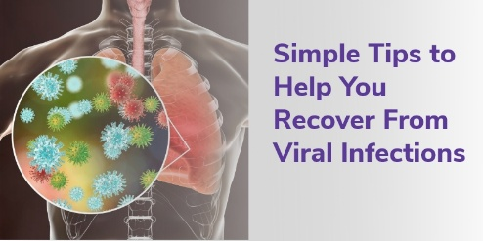**Gargling with salt water**: Mix 1/4 teaspoon of salt with 8 ounces of warm water and gargle several times a day to help reduce throat inflammation.
     3. **Steam inhalation:** Inhale steam from a bowl of hot water or a steam humidifier to help loosen mucus and ease congestion.
     4. **Warm compresses:** Apply a warm compress to the face or body to help relieve sinus pressure and muscle aches.
     5. **Herbal teas**: Certain herbal teas, such as ginger, peppermint, or echinacea, may help alleviate symptoms and support immune function.
     6. **Ginger:** Ginger tea or ginger lozenges may help reduce inflammation and alleviate pain.
     7. **Turmeric:** Turmeric contains curcumin, which has anti-inflammatory properties that may help reduce throat inflammation.
     8. **Lemon**: Lemon juice or lemon tea may help stimulate saliva production, which can help soothe a sore throat.
     9. **Apple cider vinegar**: Mix 1/4 cup of apple cider vinegar with 8 ounces of water and gargle several times a day to help reduce inflammation.
     10. **Throat lozenges:** Lozenges containing natural ingredients like honey, ginger, or slippery elm may provide temporary pain relief.
   * 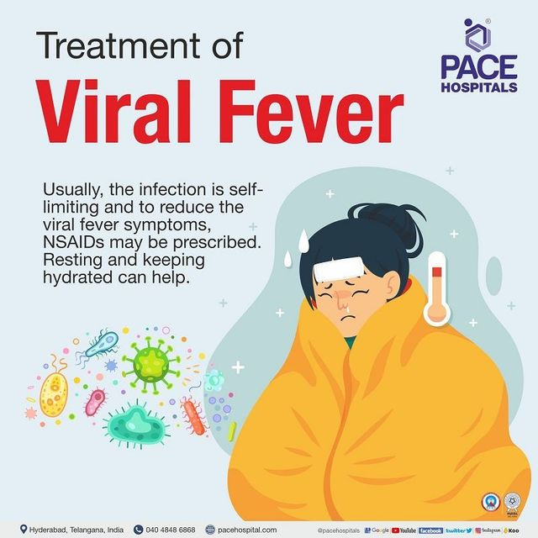**Nutritional Support**
     1. **Vitamin C**: Foods rich in vitamin C, such as citrus fruits, bell peppers, and leafy greens, may help boost immune function.
     2. **Zinc:** Include zinc-rich foods like oysters, beef, chicken, and fortified cereals in your diet to support immune function.
     3. **Probiotics**: Probiotic-rich foods like yogurt, and fermented vegetables may help support gut health and immune function.
   * **Specific Remedies for Common Symptoms**
     1. **Cough:** Try honey, ginger tea, or cough drops to soothe a cough.
     2. **Sore throat:** Gargle with salt water, try honey, or suck on throat lozenges.
     3. **Fever**: Stay hydrated, rest, and consider taking over-the-counter medications like acetaminophen or ibuprofen.
     4. **Congestion:** Try steam inhalation, use a humidifier, or take over-the-counter decongestants.
7. **Use of Antibiotics.** Antibiotics are generally **ineffective against viral infections**, and their misuse can lead to serious consequences.
   * **Why Antibiotics Don't Work on Viruses**
     1. **Target difference:** Antibiotics are designed to kill or inhibit bacteria by targeting structures like cell walls or protein synthesis machinery — things viruses *don’t have*.
     2. **Viruses reproduce inside your cells**, using your own cellular machinery, so antibiotics can't reach or affect them.
   * **When to Use Antibiotics**
     1. **For bacterial infections only**, such as:
        1. Strep throat (caused by *Streptococcus*)
        2. Urinary tract infections (UTIs)
        3. Bacterial pneumonia
        4. Some skin infections
   * **When Antibiotics Are Misused for Viral Infections**
   * **Common viral infections often wrongly treated with antibiotics:**
     1. The flu
     2. Colds
     3. COVID-19 (unless there’s a bacterial co-infection)
     4. Bronchitis
     5. Viral sore throats (unless strep is confirmed)
   * **Risks of misuse:**
     1. **Antibiotic resistance:** Bacteria evolve to become stronger and no longer respond to antibiotics.
     2. **Side effects:** Diarrhea, allergic reactions, gut micro biome imbalance.
     3. **Unnecessary cost and treatment complications.**
8. **Important**: While these remedies may help alleviate symptoms, it's essential to consult MI Room / healthcare center if:
   * Your symptoms worsen or persist
   * You have a weakened immune system
   * You're unsure about the cause of your symptoms
   * You're considering taking any supplements or medications.